I Will Save You on That Day
October 2, 2018
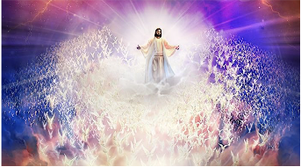
I will save you on that Day
Oh, I'll save you on that Day
Yes, I'll save you on that Day
(save us on that Day)
I will save you on that Day

Oh, I'll save you on that Day
(He will save us on that Day)
Oh, I'll save you on that Day
(He will save us on that Day)
Yes, I'll save you on that Day
I will save you on that Day

He will save you

